Дата: 18-20.05.20.

Тема: Песни В.Я Шаинского

Владимир Яковлевич Шаинский (12.12.1925 — 25.12.2017)

советский и российский композитор. Народный артист РСФСР.

Лауреат Государственной премии СССР. Известен как автор

множества популярных песен для детей.

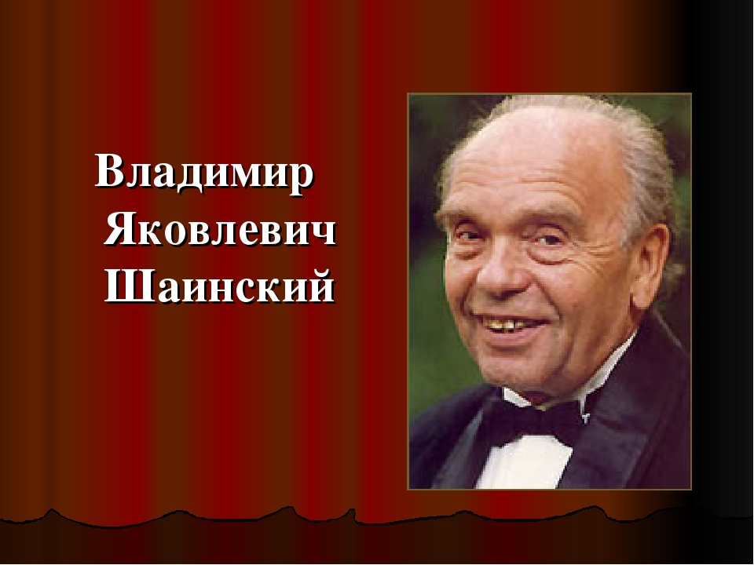

Вспомните детские песни В.Я.Шаиского

и впишите в пустые клеточки название песен.

К каждому заданию прикреплена иллюстрированная картинка,

которая дает подсказку на правильный ответ.

Выполненное задание присылайте мне по ватсапу.

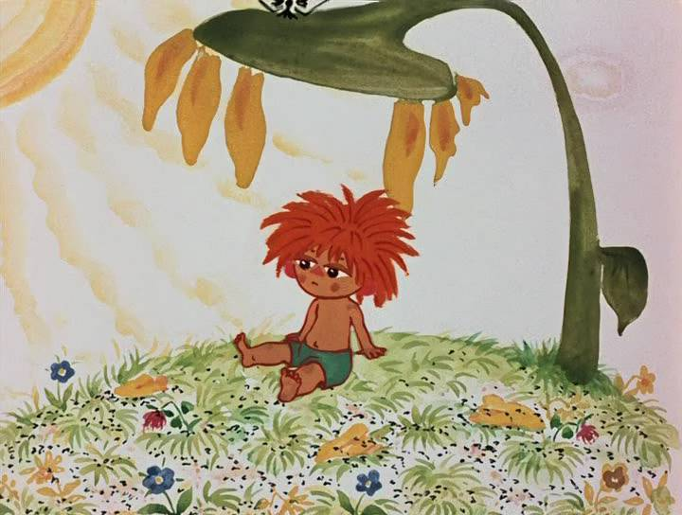Задание № 1

|  |  |  |  |  |  |  |
| --- | --- | --- | --- | --- | --- | --- |
|  |  |  |  |  |  |  |

Задание № 2

|  |  |  |  |  |  |  |  |  |  |  |  |  |  |
| --- | --- | --- | --- | --- | --- | --- | --- | --- | --- | --- | --- | --- | --- |
|  |  |  |  |  |  |  |  |  |  |  |  |  |  |

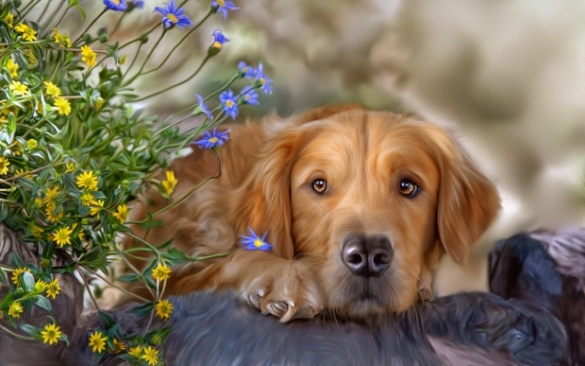

Задание № 3

|  |  |  |  |  |  |  |  |  |  |  |  |  |
| --- | --- | --- | --- | --- | --- | --- | --- | --- | --- | --- | --- | --- |
|  |  |  |  |  |  |  |  |  |  |  |  |  |



|  |  |  |  |  |  |
| --- | --- | --- | --- | --- | --- |
|  |  |  |  |  |  |

Задание № 4

|  |  |  |  |  |  |  |  |  |  |  |  |  |  |  |  |  |  |  |
| --- | --- | --- | --- | --- | --- | --- | --- | --- | --- | --- | --- | --- | --- | --- | --- | --- | --- | --- |
|  |  |  |  |  |  |  |  |  |  |  |  |  |  |  |  |  |  |  |

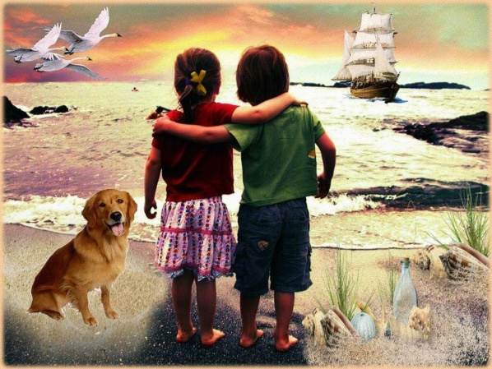

|  |  |  |  |  |  |
| --- | --- | --- | --- | --- | --- |
|  |  |  |  |  |  |

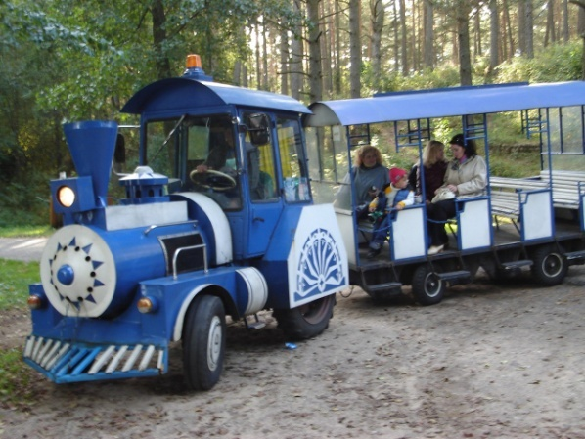

Задание № 5

|  |  |  |  |  |  |  |  |  |  |  |  |  |
| --- | --- | --- | --- | --- | --- | --- | --- | --- | --- | --- | --- | --- |
|  |  |  |  |  |  |  |  |  |  |  |  |  |

Задание № 6

|  |  |  |  |  |  |  |  |  |  |  |  |  |  |
| --- | --- | --- | --- | --- | --- | --- | --- | --- | --- | --- | --- | --- | --- |
|  |  |  |  |  |  |  |  |  |  |  |  |  |  |

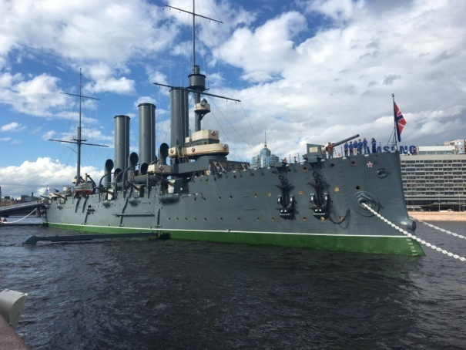

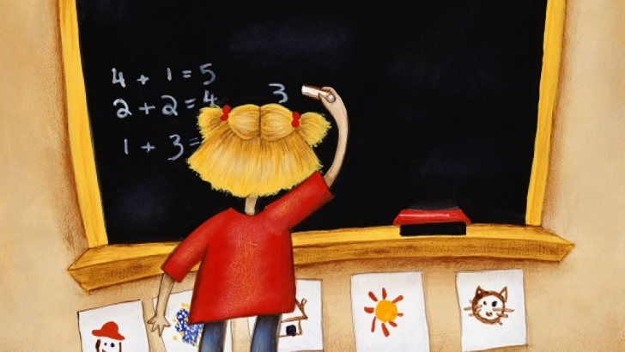Задание № 7

|  |  |  |  |  |  |  |  |  |
| --- | --- | --- | --- | --- | --- | --- | --- | --- |
|  |  |  |  |  |  |  |  |  |

|  |  |  |  |  |  |  |
| --- | --- | --- | --- | --- | --- | --- |
|  |  |  |  |  |  |  |

Задание № 8

|  |  |  |  |  |  |  |  |  |  |  |  |  |  |  |  |  |  |
| --- | --- | --- | --- | --- | --- | --- | --- | --- | --- | --- | --- | --- | --- | --- | --- | --- | --- |
|  |  |  |  |  |  |  |  |  |  |  |  |  |  |  |  |  |  |

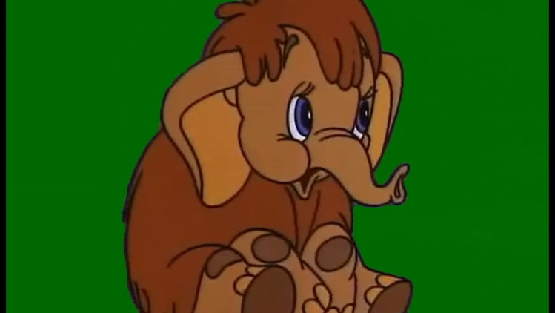

Задание № 9

|  |  |  |  |  |  |
| --- | --- | --- | --- | --- | --- |
|  |  |  |  |  |  |

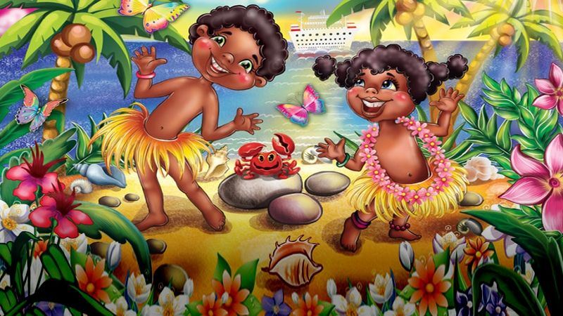Задание № 10

|  |  |  |  |  |  |  |  |  |  |  |
| --- | --- | --- | --- | --- | --- | --- | --- | --- | --- | --- |
|  |  |  |  |  |  |  |  |  |  |  |

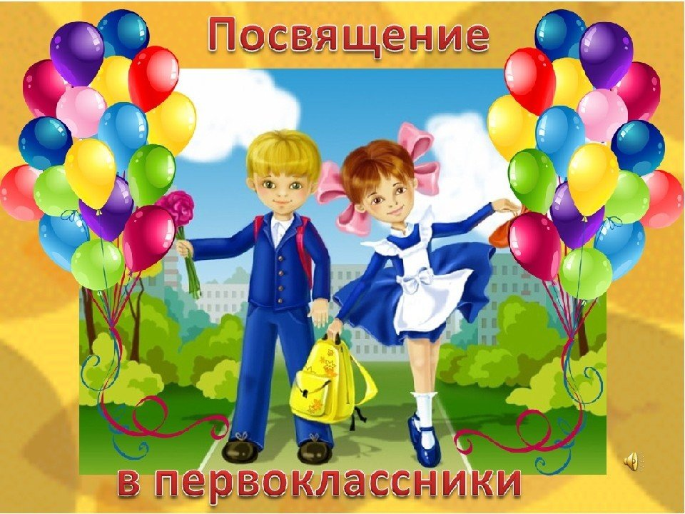

Задание № 11

|  |  |  |  |  |  |  |  |  |  |  |
| --- | --- | --- | --- | --- | --- | --- | --- | --- | --- | --- |
|  |  |  |  |  |  |  |  |  |  |  |